EXPT NO: 2 | COMPARATIVE STUDY OF ACTIVATION FUNCTIONS AND OPTIMIZATION ALGORITHMS IN DEEP LEARNING
DATE:

PRE-LAB QUESTIONS (PROVIDE BRIEF ANSWERS TO THE FOLLOWING QUESTIONS)

- What is the purpose of an activation function in an Artificial Neural Network?

An activation function introduces non-linearity into a neural network, allowing it to learn complex patterns and relationships in data. It determines whether a neuron should be activated based on its input.

- Differentiate between the Sigmoid, Tanh, and ReLU activation functions based on their output range and mathematical properties.

Activation function | Output range | Mathematical properties
Sigmoid | 0 to 1 | Smooth, S-shaped curve; commonly used for binary classification.
Tanh | -1 to 1 | S-shaped curve centered around zero; produces both positive and negative outputs.
ReLU | 0 to infinity | Outputs 0 for negative inputs and the input itself for positive values; computationally efficient and widely used in hidden layers.

- Why is an optimization algorithm required during neural network training?

An optimization algorithm is used to minimize the loss or error of a neural network by updating its weights and biases. It helps the model learn the best parameters that produce accurate predictions. Examples include Gradient Descent, SGD, Adam, and RMSprop.

- What is the difference between Batch Gradient Descent, Stochastic Gradient Descent (SGD), and Mini-Batch Gradient Descent?

• Batch Gradient Descent: Uses the entire training dataset to calculate the gradient and update weights. It is stable but can be slow for large datasets.
• Stochastic Gradient Descent (SGD): Uses one training sample at a time to update weights. It is faster but has more fluctuations during training.
• Mini-Batch Gradient Descent: Uses a small group of samples (mini-batch) for each update. It provides a good balance between speed and stability and is commonly used in deep learning.

- Explain the role of Google Colab and GitHub in deep learning experiment management.

Google Colab provides a cloud-based environment for writing and executing deep learning code, often with access to GPUs and TPUs without requiring powerful local hardware. GitHub is used to store, version-control, and share source code, datasets references, notebooks, and project documentation.

AIM
To analyze the impact of different activation functions and optimization algorithms on the performance of Artificial Neural Networks (ANNs) and to learn best practices for managing deep learning experiments using cloud-based tools and version control.

SOFTWARE REQUIREMENTS
- Python
- TensorFlow or PyTorch
- Google Colab
- GitHub
- Matplotlib

OBJECTIVES
Students will be able to:
- Understand the role of activation functions in neural networks.
- Visualize and compare commonly used activation functions.
- Evaluate the performance of different activation functions in ANN models.
- Analyze various gradient-based optimization algorithms.
- Compare optimizer convergence and model accuracy.
- Learn experiment management using Google Colab, Google Drive, and GitHub.
- Maintain reproducible deep learning experiments using version control.

PROCEDURE
PART A: VISUALIZATION OF ACTIVATION FUNCTIONS
Implement and plot the following activation functions:
- Sigmoid
- Tanh
- ReLU
Compare their:
- Output range
- Saturation regions
- Gradient behavior
- Computational efficiency
- Typical applications

(CODE: CONATAINS STUDENT ROLL NOS
SCREENSHOT OF CODE
SCREENSHOT OF OUTPUT)

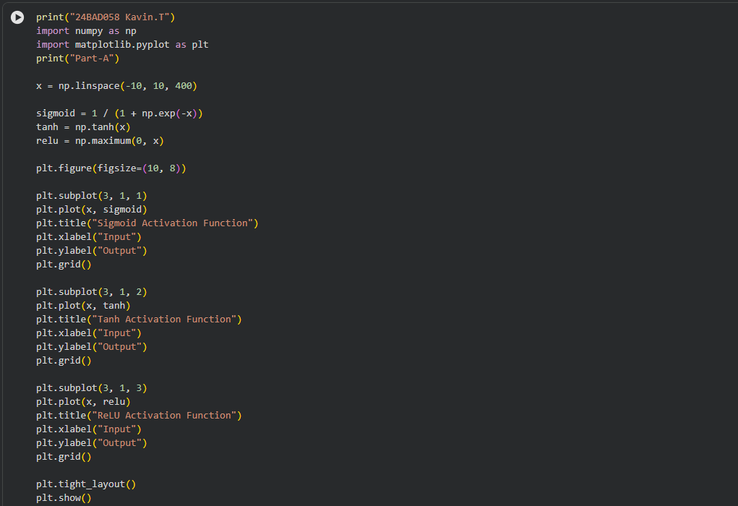

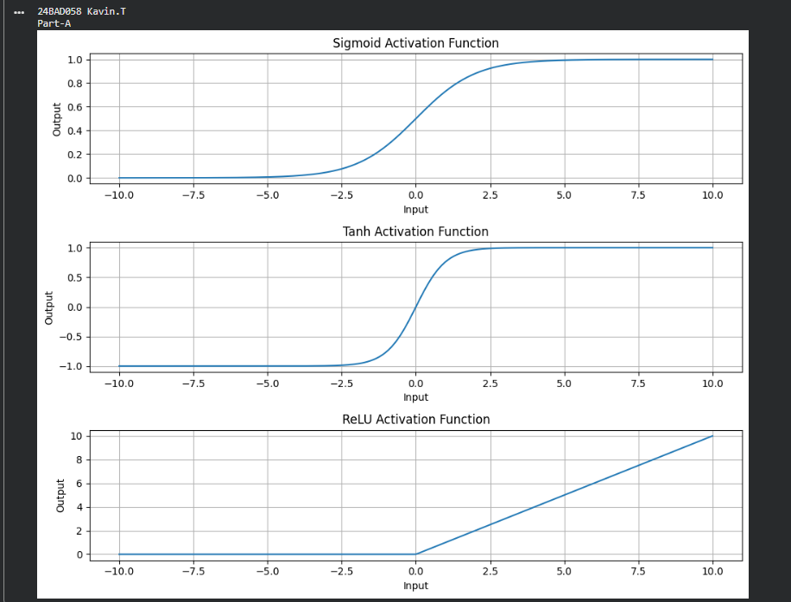

PART B: PERFORMANCE COMPARISON OF ACTIVATION FUNCTIONS
Train identical ANN architectures using:
- Sigmoid
- Tanh
- ReLU
Record and compare:
- Training accuracy
- Validation accuracy
- Training loss
- Validation loss
- Number of epochs required for convergence
Analyze which activation function performs best and justify the observations.

(CODE: CONATAINS STUDENT ROLL NOS
SCREENSHOT OF CODE
SCREENSHOT OF OUTPUT)

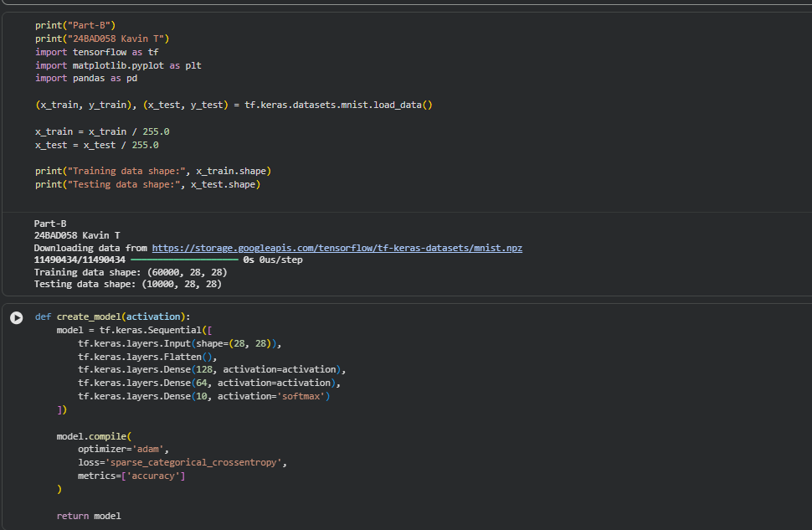

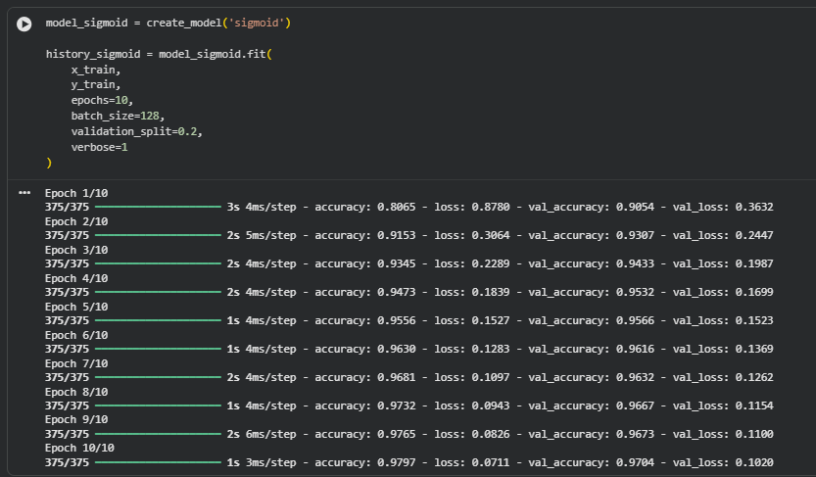

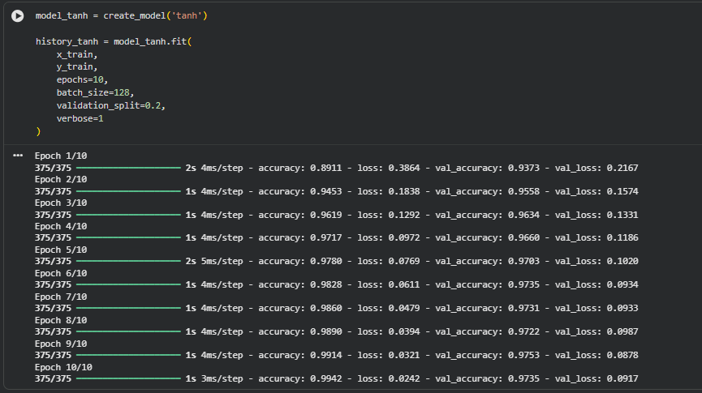

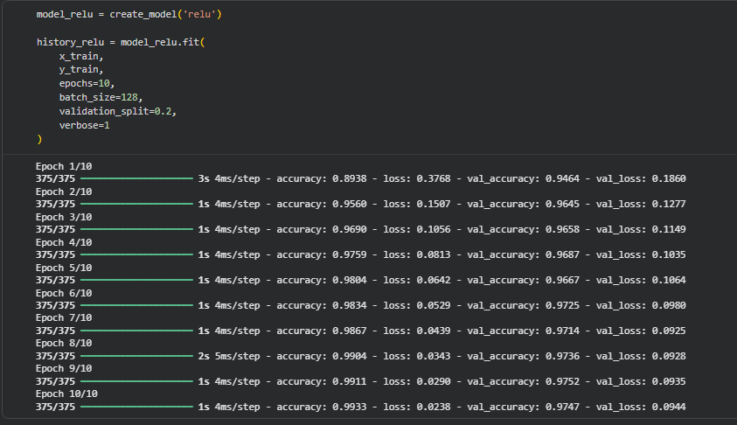

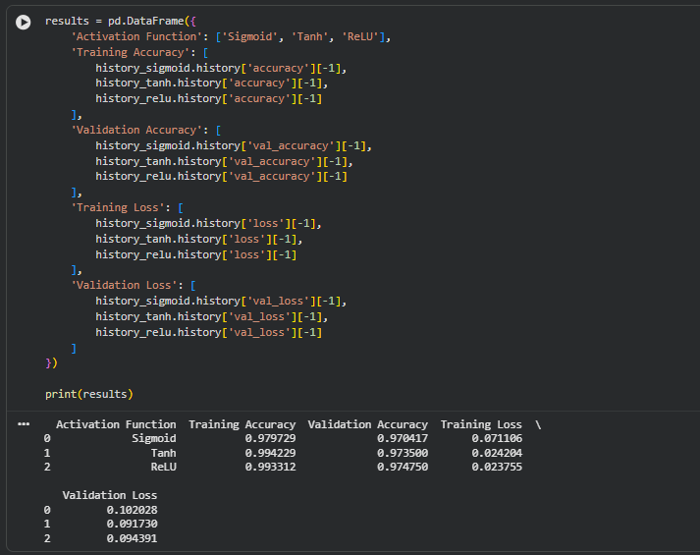

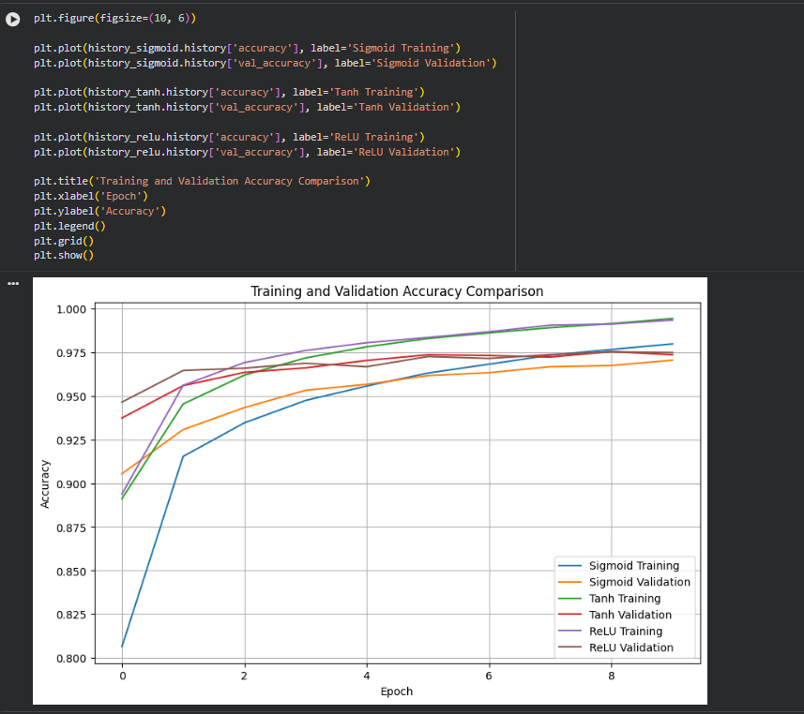

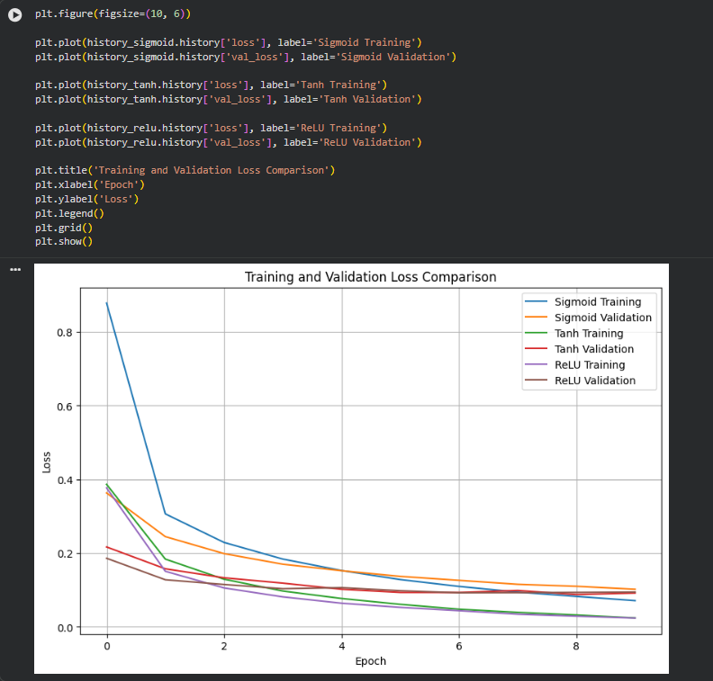

PART C: COMPARISON OF OPTIMIZATION ALGORITHMS
Train the same ANN using:
- Stochastic Gradient Descent (SGD)
- Momentum
- RMSProp
- Adam
Compare:
- Training loss
- Validation loss
- Convergence speed
- Final training accuracy
- Final validation accuracy
Visualize:
- Loss vs Epoch
- Accuracy vs Epoch
Discuss which optimizer converges faster and produces better generalization.

(CODE: CONATAINS STUDENT ROLL NOS
SCREENSHOT OF CODE
SCREENSHOT OF OUTPUT)

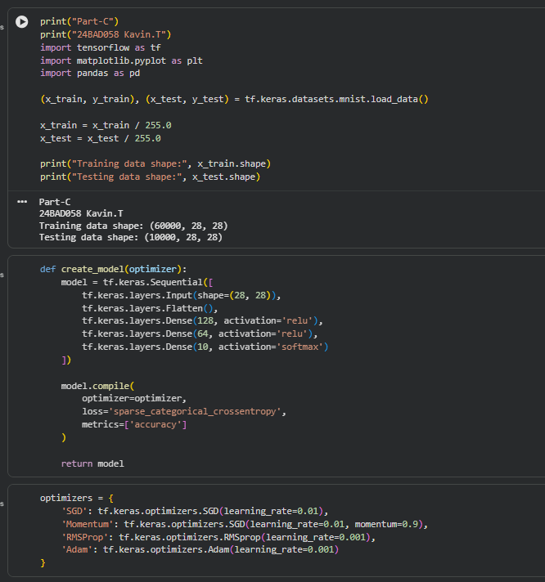

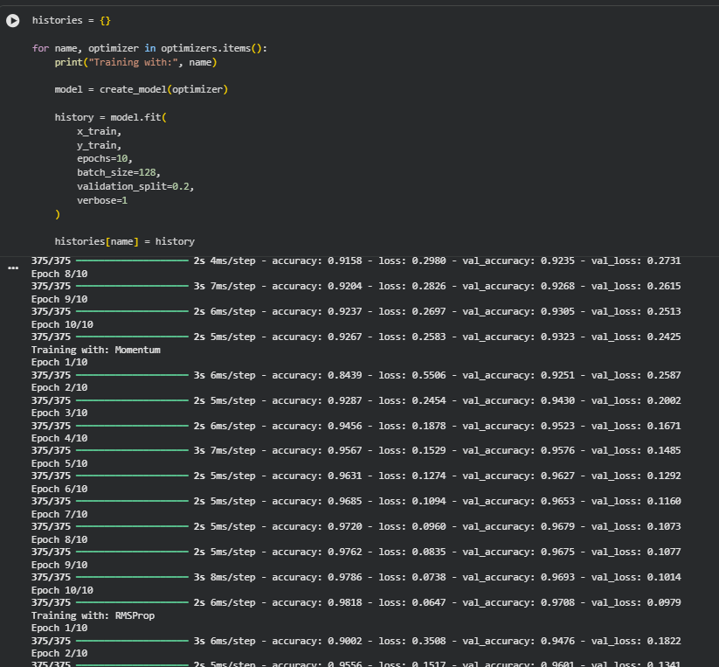

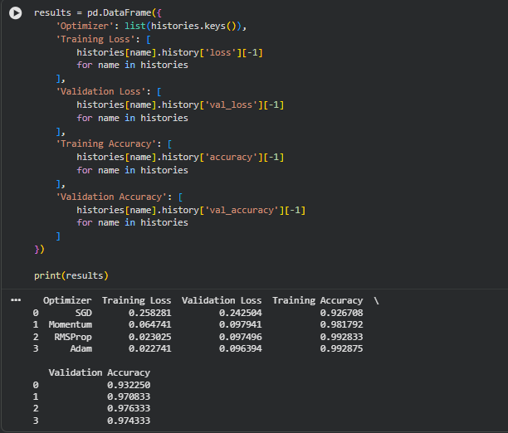

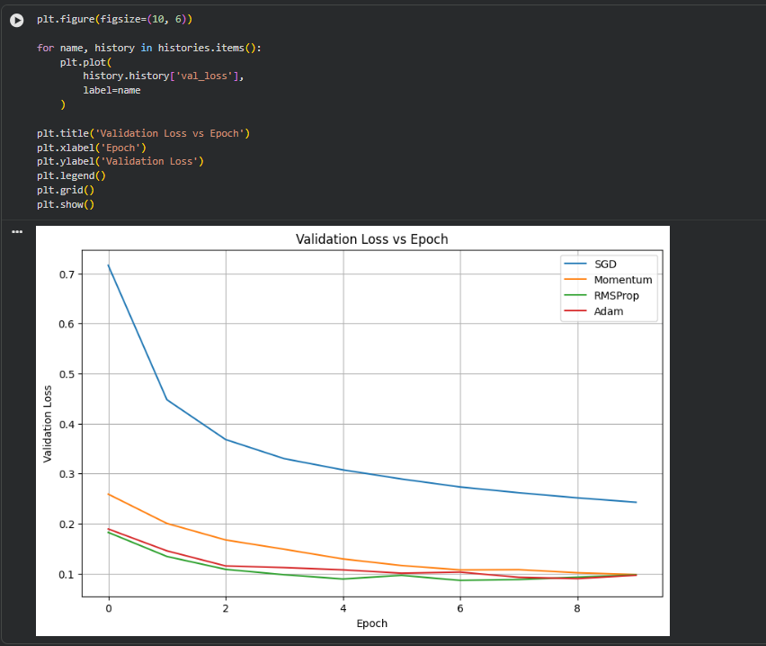

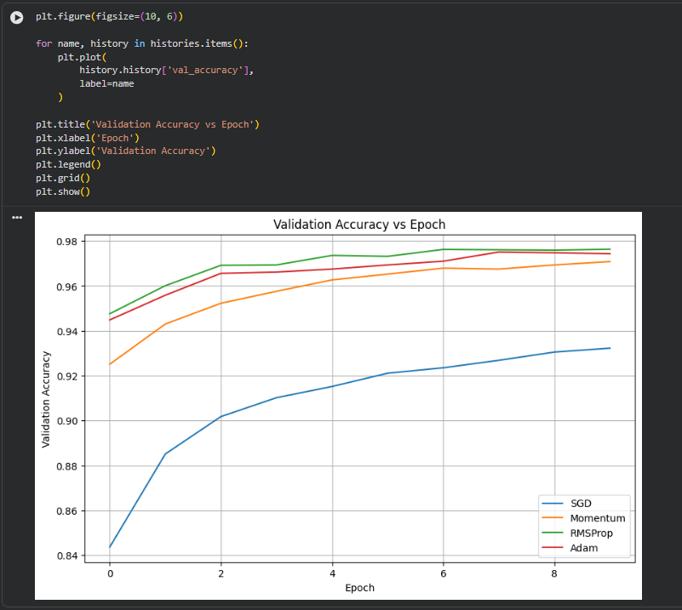

PART D: DEEP LEARNING EXPERIMENT MANAGEMENT
Perform the following tasks:
- Create a Google Colab notebook.
- Mount Google Drive.
- Save notebooks and trained models.
- Create a GitHub repository.
- Upload notebooks to GitHub.
- Commit changes and maintain version history using Git.
- Document the experiment using a README.md file.

(CODE: CONATAINS STUDENT ROLL NOS
SCREENSHOT OF CODE
SCREENSHOT OF OUTPUT)

EXPECTED OUTCOME
Students will understand how activation functions and optimization algorithms influence neural network learning and performance. They will also gain practical experience in organizing, documenting, and maintaining reproducible deep learning experiments using cloud platforms and Git-based version control.

POST-LAB QUESTIONS (PROVIDE BRIEF ANSWERS TO THE FOLLOWING QUESTIONS)

- Which activation function achieved the best performance in your experiment? Justify your answer using the obtained results.

ReLU achieved the best performance in my experiment. It obtained the highest validation accuracy and showed faster reduction in training and validation loss compared to Sigmoid and Tanh. This indicates that ReLU helped the ANN learn the patterns more efficiently and converge faster.

- Compare the convergence behavior of SGD, Momentum, RMSProp, and Adam based on the training graphs.

SGD showed slower convergence and more gradual improvement. Momentum converged faster than basic SGD because it uses previous updates to accelerate learning. RMSProp adapted the learning rate for each parameter and provided faster and more stable convergence. Adam generally showed the fastest convergence with a rapid decrease in loss and quick improvement in accuracy. Therefore, Adam performed best overall in terms of convergence speed in my experiment.

- Why does the ReLU activation function generally train faster than the Sigmoid activation function?

ReLU generally trains faster because it has a simple mathematical operation and does not saturate for positive input values. Therefore, it maintains stronger gradients and reduces the vanishing gradient problem. Sigmoid can produce very small gradients for large positive or negative inputs, which slows down learning in deep networks.

- How does version control using GitHub improve the reproducibility and collaboration of deep learning projects?

GitHub improves reproducibility by maintaining different versions of code, notebooks, and documentation through commits and version history. It allows researchers to track changes, return to previous versions, and share the exact code used for experiments. It also improves collaboration because multiple team members can access the project, contribute changes, and manage the project using Git.

- If you were asked to train a deep neural network for an image classification task, which activation function and optimizer would you choose? Justify your selection based on the experimental observations.

I would choose ReLU as the activation function for the hidden layers and Adam as the optimizer. ReLU generally trains faster and reduces the vanishing gradient problem, making it suitable for deep neural networks. Adam provides fast and stable convergence by adapting the learning rate during training. Based on the experimental observations, the combination of ReLU and Adam is expected to provide efficient training and good generalization for image classification tasks.

ASSESSMENT
Description | Max Marks | Marks Awarded
Pre Lab Exercise | 5
In Lab Exercise | 10
Post Lab Exercise | 5
Viva | 10
Total | 30
Faculty Signature

